- Resolve Merge Conflicts
Outcome:
A merge conflict is intentionally created, manually resolved, and successfully pushed to GitHub.
Prerequisites:
- Local Git repository with remote on GitHub
- Two branches or two users editing same file
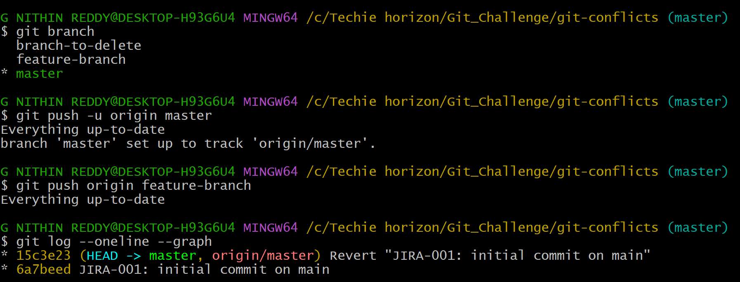
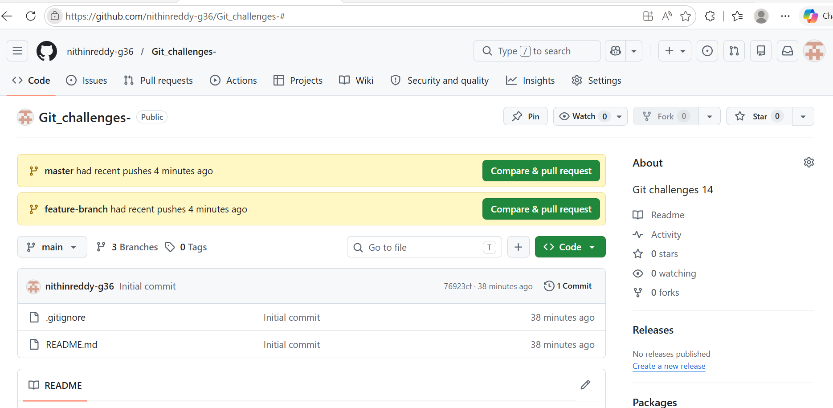
Explanation
In real teams, two developers often edit the same line of code simultaneously. Git can't decide which change to keep — so it creates a merge conflict. You must manually resolve it. This is one of the most common daily Git tasks.
Objective: Create an intentional merge conflict between two branches editing the same line, resolve it manually, and push the result.
Validation:
git log shows merge commit. GitHub shows resolved file with no conflict markers.

Steps:

- Created a repo and made initial commit on master
- Created feature-branch, edited same line in conflict.txt as User B
- Switched to master, edited same line as User A
- Ran git merge feature-branch — conflict markers appeared
- Manually removed markers, kept merged content
- Ran git add conflict.txt then git commit
- Pushed both branches to GitHub
Outcome: Merge conflict was intentionally created, manually resolved, and pushed. git log --oneline --graph confirmed the merge commit with all branches visible.
Common Errors:
Error | Cause | Resolution
Conflict markers left in file | Forgot to remove <<< === >>> | Edit file again and remove markers
Merge aborted | Unclean working directory | git stash before merging

- Recover Deleted Branch
Outcome:
A deleted local branch is successfully recovered using git reflog.
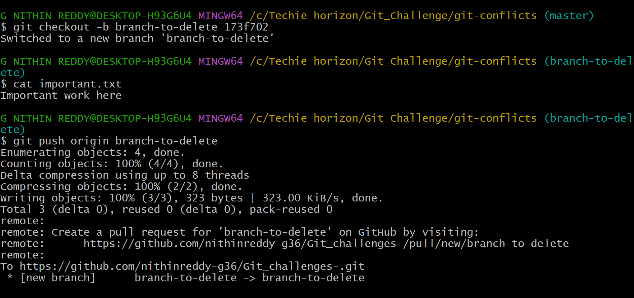
Objective: Delete a local branch and recover it using git reflog.
Prerequisites:
- Local repository with at least one branch with commits
Validation:
git branch shows recovery-branch restored.
git log shows "Important commit on recovery-branch" back in history.
Explanation: Git reflog records every movement of HEAD, even after branch deletion. Branches are just pointers to commits — when a branch is deleted, the commits remain in Git objects temporarily. Reflog lets you find and restore them before garbage collection runs.
Steps:
Created branch-to-delete with a commit containing important.txt
Switched to master and deleted it with git branch -D branch-to-delete
Ran git reflog and found the deleted branch's last commit SHA
Ran git checkout -b branch-to-delete <SHA> to restore it
Verified important.txt was back and pushed to GitHub
Outcome: Deleted branch was fully recovered. File and commit history were restored exactly as before deletion.
Common Errors:
Error | Cause | Resolution
Hash not found in reflog | Garbage collection ran | Recovery not possible after GC
Wrong branch state | Checked out wrong hash | Re-check reflog for correct entry

- Undo Wrong Push
Outcome:
A wrongly pushed commit is undone on GitHub without rewriting or losing commit history.
Objective:
Push a wrong commit to GitHub and undo it without losing history using git revert.
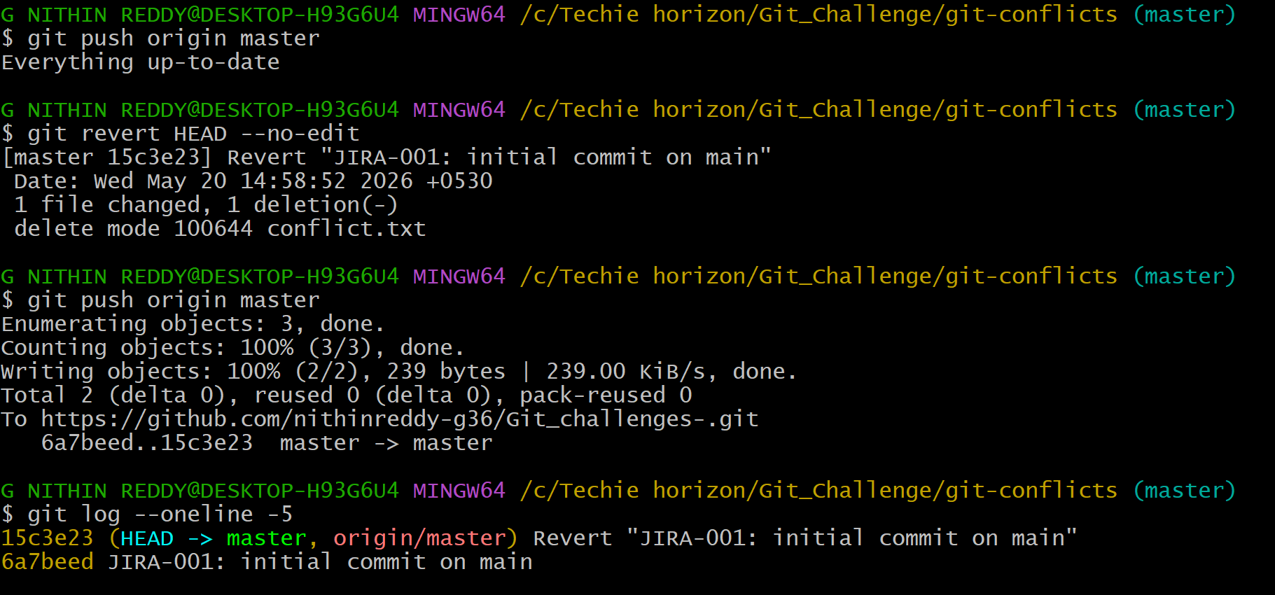
Explanation
I pushed a wrong commit to GitHub. git revert creates a new commit that undoes the change — history is preserved, safe for shared branches.
Prerequisites:
- Repository with remote on GitHub
- A commit already pushed that needs to be undone
Step-by-Step Implementation:
- Step 1: Push a Wrong Commit
- echo "wrong code" > wrong.txt
- git add wrong.txt
- git commit -m "Wrong commit pushed by mistake"
- git push origin main
- Step 2: Get the Commit Hash
- git log --oneline

- Output:
- abc1234 Wrong commit pushed by mistake
- Step 3: Revert the Commit
- git revert abc1234
- (Editor opens → Save default message)
- Step 4: Push the Revert Commit
- git push origin main
Validation:
- GitHub shows a new "Revert" commit.
- wrong.txt is removed from latest code but full history is intact.
Common Errors:
Error | Cause | Resolution
Conflict during revert | Later commits depend on reverted code | Resolve conflicts manually and commit
Tried force push instead | Misunderstood reset vs revert | Always use revert on shared/remote branches

Outcome: Wrong commit was undone safely. Git log showed the original wrong commit and the revert commit above it — full history preserved.
- Amend a Commit
Outcome:
A missing file is added to the most recent commit using git commit --amend without creating a new commit.
Objective:
Make a commit then add a missing file to it using git commit --amend.
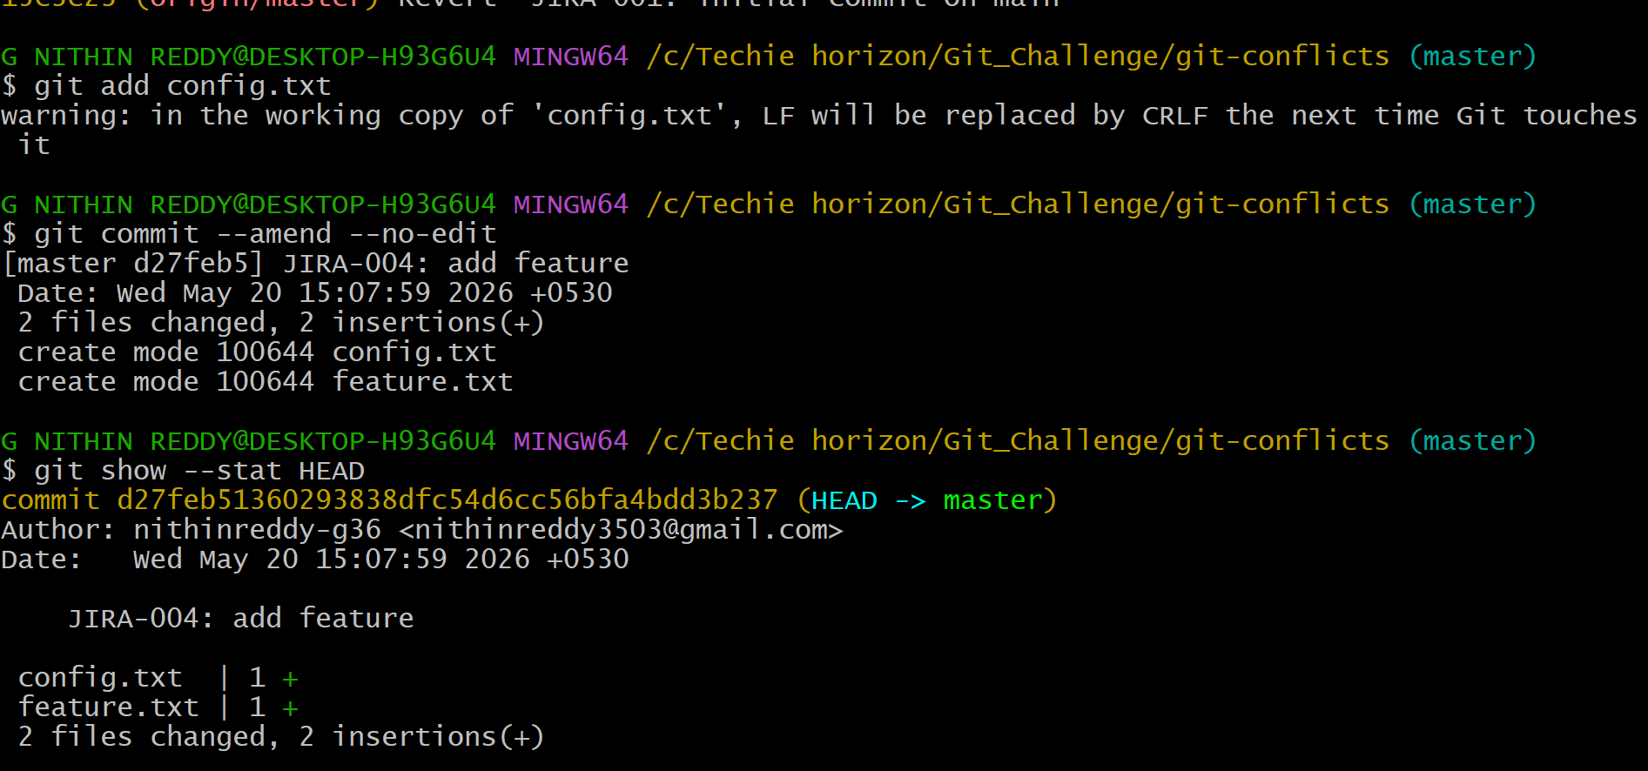
Explanation
Committed feature.txt but intentionally left out config.txt. Then staged the missing file with git add config.txt and ran git commit --amend --no-edit to rewrite the last commit to include it. Used git show --stat HEAD to confirm both files appeared in one single commit. Pushed with --force because amend changes the commit SHA.
Prerequisites:
- At least one commit in local repository
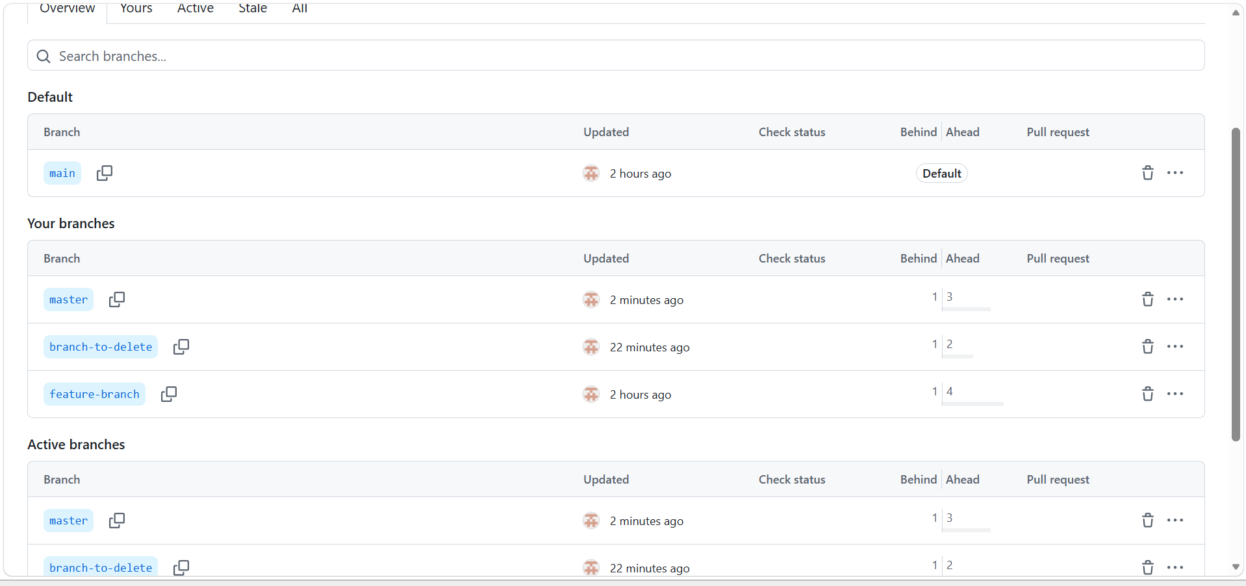
Outcome: Both files appeared in one single amended commit. No extra commit was created in the log.
Step-by-Step Implementation:
Step 1: Make Initial Commit (Missing a File)
echo "Main file" > main.txt
git add main.txt
git commit -m "Add main file"
Step 2: Realize a File Was Missed
echo "Missing file content" > missed.txt
Step 3: Stage the Missing File
git add missed.txt
Step 4: Amend the Last Commit
git commit --amend -m "Add main file and missed file"
Step 5: Push (Force Required)
git push origin main --force
Validation:
git log --oneline shows only ONE commit (not two).
git show HEAD displays both main.txt and missed.txt in the same commit.

- Cherry-pick a Commit
Outcome:
A specific commit from one branch is applied to another branch without merging the entire branch.
Objective:
Squash multiple WIP commits into one single clean commit.
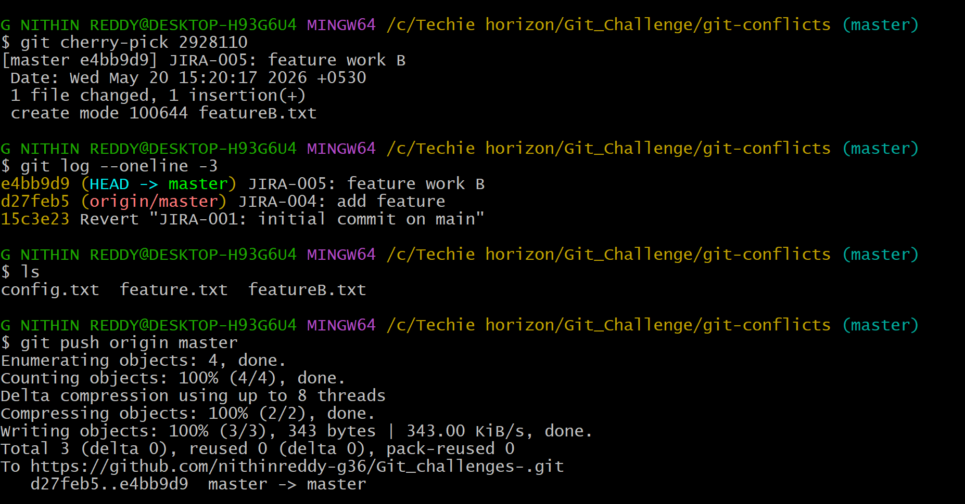
Explanation
Created branch cherry-source with 3 commits — feature A, a hotfix, and feature B. Used git log --oneline to note the hotfix commit SHA. Switched to master and ran git cherry-pick <SHA> to apply only the hotfix onto master. Verified that only hotfix.txt appeared on master, not the other two feature files.
Prerequisites:
- Repository with at least two branches
- A commit on one branch that is needed on another
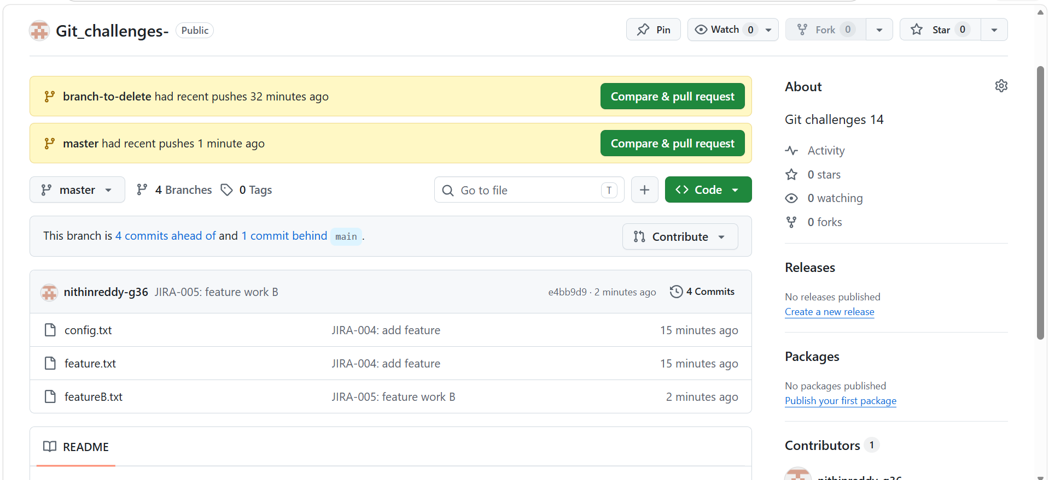
Outcome: Four messy WIP commits were squashed into one clean commit. Git log showed only one entry where there were four before.
Step-by-Step Implementation:
Step 1: Create a Commit on Feature Branch
git checkout -b feature-branch
echo "Critical fix" > fix.txt
git add fix.txt
git commit -m "JIRA-101: Critical bug fix"
git log --oneline
→ Note the commit hash e.g. abc1234
Step 2: Switch to Target Branch (Main)
git checkout main
Step 3: Cherry-pick the Specific Commit
git cherry-pick abc1234
Step 4: Push to Remote
git push origin main
Validation:
git log on main shows "JIRA-101: Critical bug fix" commit.
fix.txt is present on main but full feature-branch is NOT merged.
Common Errors:
Error | Cause | Resolution
Cherry-pick conflict | Same file modified in both branches | Resolve conflict, then git cherry-pick --continue
Duplicate commits | Cherry-picked already merged commit | Check log before cherry-picking

- Interactive Rebase
Outcome:
Multiple messy commits are reordered and squashed into a single clean commit using interactive rebase.
Objective:
Squash multiple WIP commits into one single clean commit.
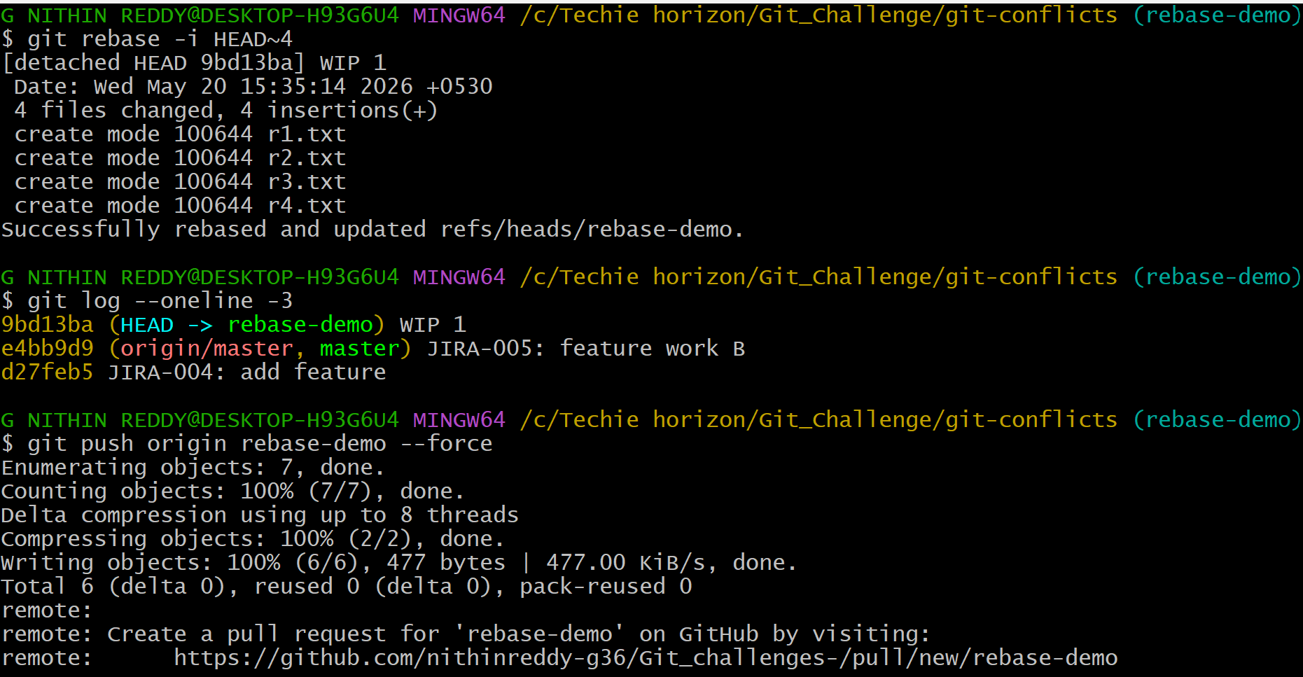
Explanation
Created branch rebase-demo and made 4 WIP commits with messages "WIP 1" through "WIP 4". Ran git rebase -i HEAD~4 which opened an editor. Changed lines 2, 3, 4 from pick to squash. Saved — a second editor opened for the combined message. Wrote "JIRA-006: complete feature implementation". Git log then showed only 1 clean commit where there were 4 before.
Prerequisites:
Branch with 3 or more commits to squash
Step-by-Step Implementation:
Step 1: Create Multiple Commits
echo "part1" > rebase.txt && git add . && git commit -m "WIP part 1"
echo "part2" >> rebase.txt && git add . && git commit -m "WIP part 2"
echo "part3" >> rebase.txt && git add . && git commit -m "WIP part 3"
Step 2: Start Interactive Rebase (Last 3 Commits)
git rebase -i HEAD~3
Step 3: Edit the Rebase File
Editor opens showing:
pick a1b2c3 WIP part 1
pick d4e5f6 WIP part 2
pick g7h8i9 WIP part 3

Change to:
pick a1b2c3 WIP part 1
squash d4e5f6 WIP part 2
squash g7h8i9 WIP part 3

Save and close.
Step 4: Write Final Commit Message
Editor opens for final message → Type:
"feat: Complete rebase feature implementation"
Save and close.
Step 5: Push
git push origin feature-branch --force
Validation:
git log --oneline shows ONE clean commit replacing the three WIP commits.
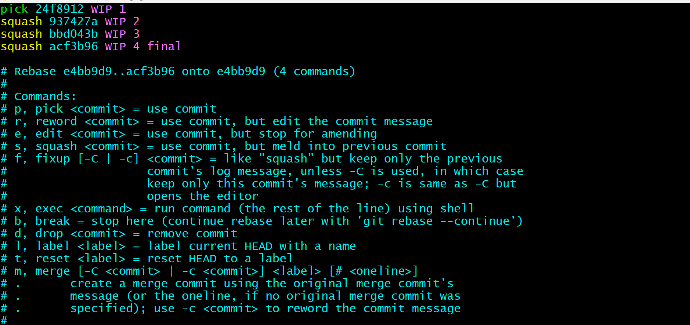
Outcome: Four messy WIP commits were squashed into one clean commit. Git log showed only one entry where there were four before.
Common Errors:
Error | Cause | Resolution
Rebase conflict | File edited in multiple commits | Resolve each conflict, git rebase --continue
Detached HEAD after rebase | Rebase interrupted | git rebase --abort to start fresh

- Tagging & Release
Outcome:
A version tag v1.0 is created, pushed to GitHub, then deleted and restored successfully.
Objective:
Create tag v1.0, push to GitHub, delete it, then restore it.
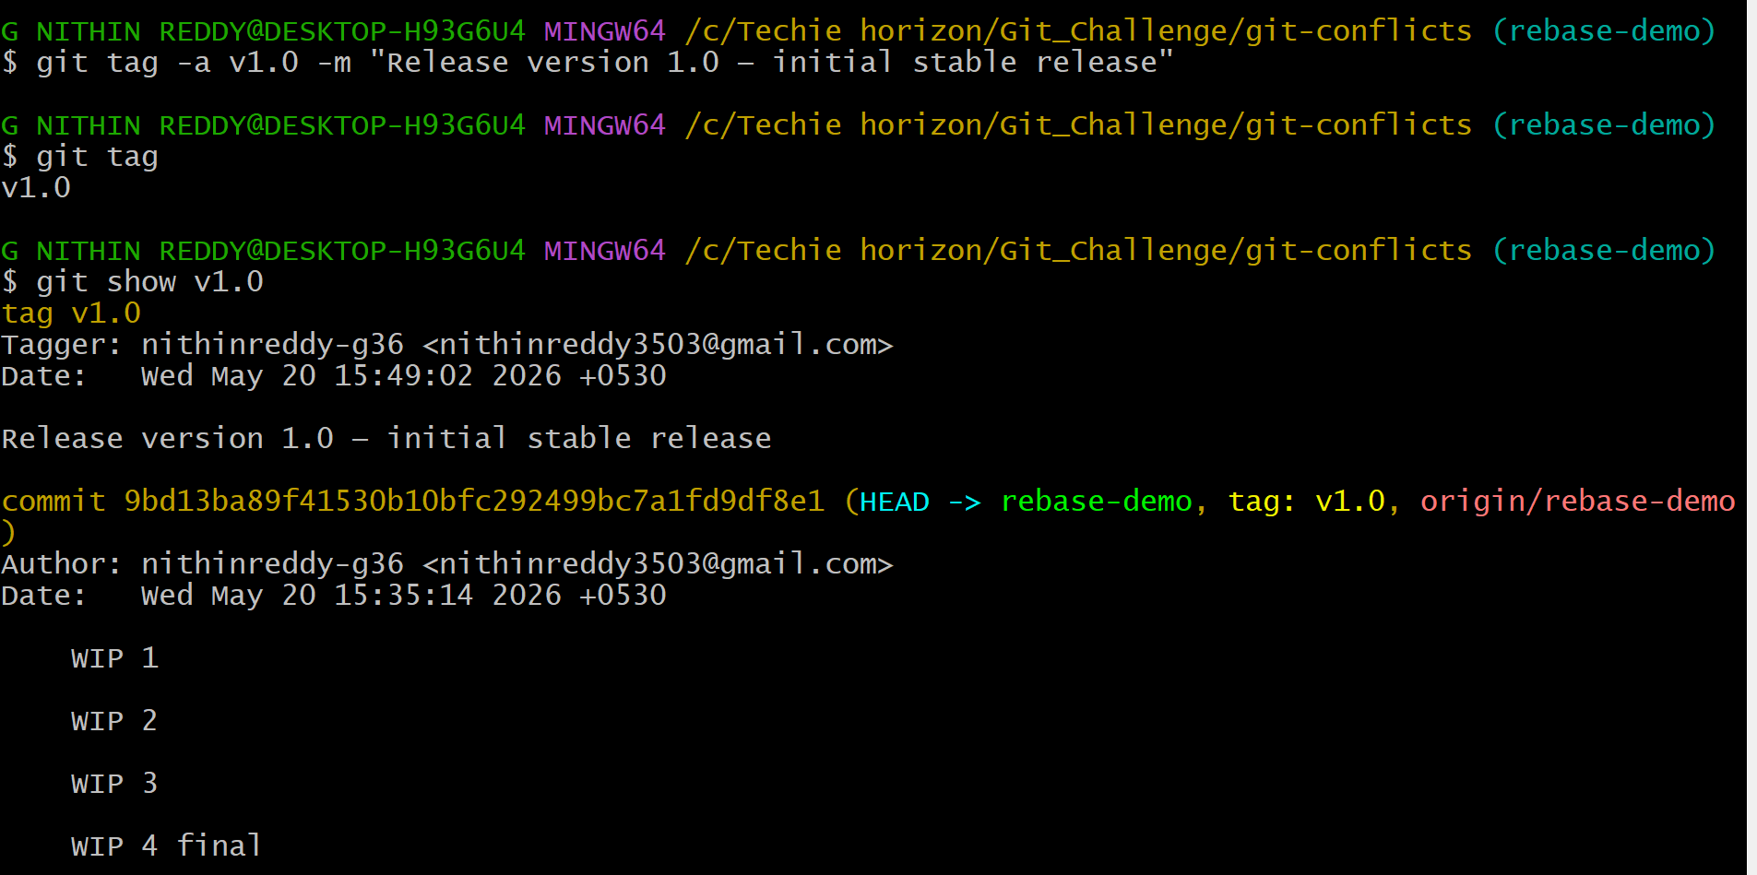
Explanation
Created an annotated tag with git tag -a v1.0 -m "Release version 1.0" and pushed it with git push origin v1.0. Confirmed it on GitHub. Then deleted it locally with git tag -d v1.0 and remotely with git push origin --delete v1.0. Found the original commit SHA from git log and recreated the tag on that exact SHA, then pushed it back.
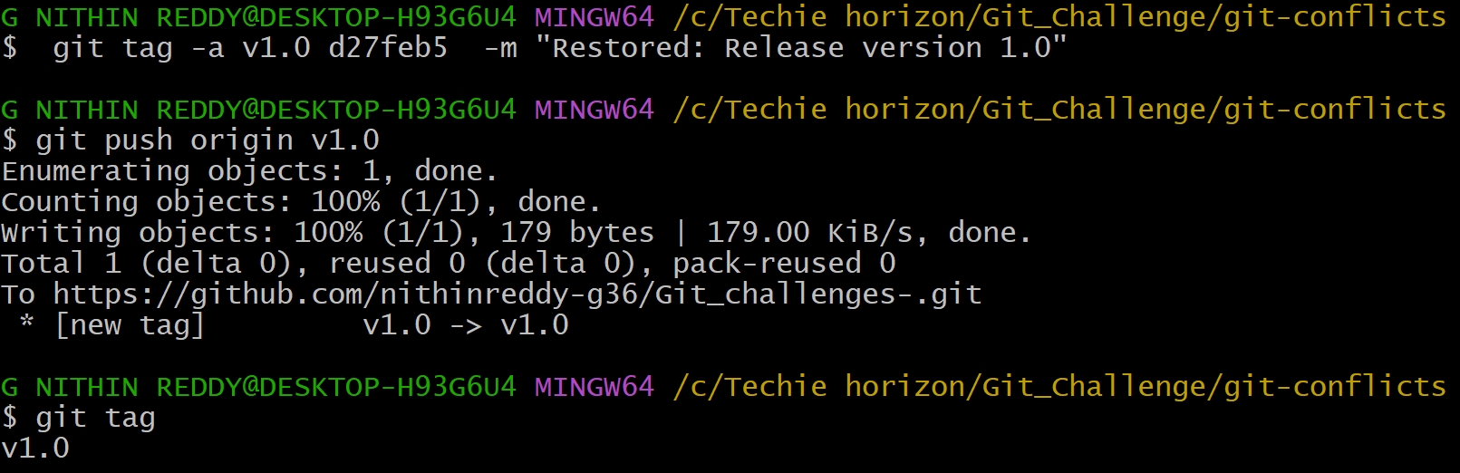
Outcome: Tag v1.0 was created, pushed, deleted from both local and remote, and fully restored. GitHub Tags page confirmed the tag after each push.
Prerequisites:
- Repository with commits on main branch
Step-by-Step Implementation:
Step 1: Create an Annotated Tag
git tag -a v1.0 -m "Release version 1.0"
Step 2: Push Tag to GitHub
git push origin v1.0
Step 3: Verify Tag on GitHub
GitHub Repo → Tags section → v1.0 visible with release notes
Step 4: Delete Tag Locally and Remotely
git tag -d v1.0
git push origin --delete v1.0
Step 5: Restore the Tag
Find the commit hash:
git log --oneline

Recreate tag on that commit:
git tag -a v1.0 <commit-hash> -m "Restored release version 1.0"
git push origin v1.0
Validation:
GitHub → Tags shows v1.0 restored with correct commit reference.
Common Errors:
Error | Cause | Resolution
Tag not on GitHub | Only created locally | git push origin <tagname>
Cannot delete remote tag | Insufficient permissions | Check GitHub branch protection rules

- Clone with Sparse Checkout
Outcome:
Only a specific subdirectory of a large repository is cloned locally using sparse checkout.
Objective:
Clone only a specific subdirectory of a repo instead of the whole repo.
Prerequisites:
A GitHub repository with multiple folders/subdirectories
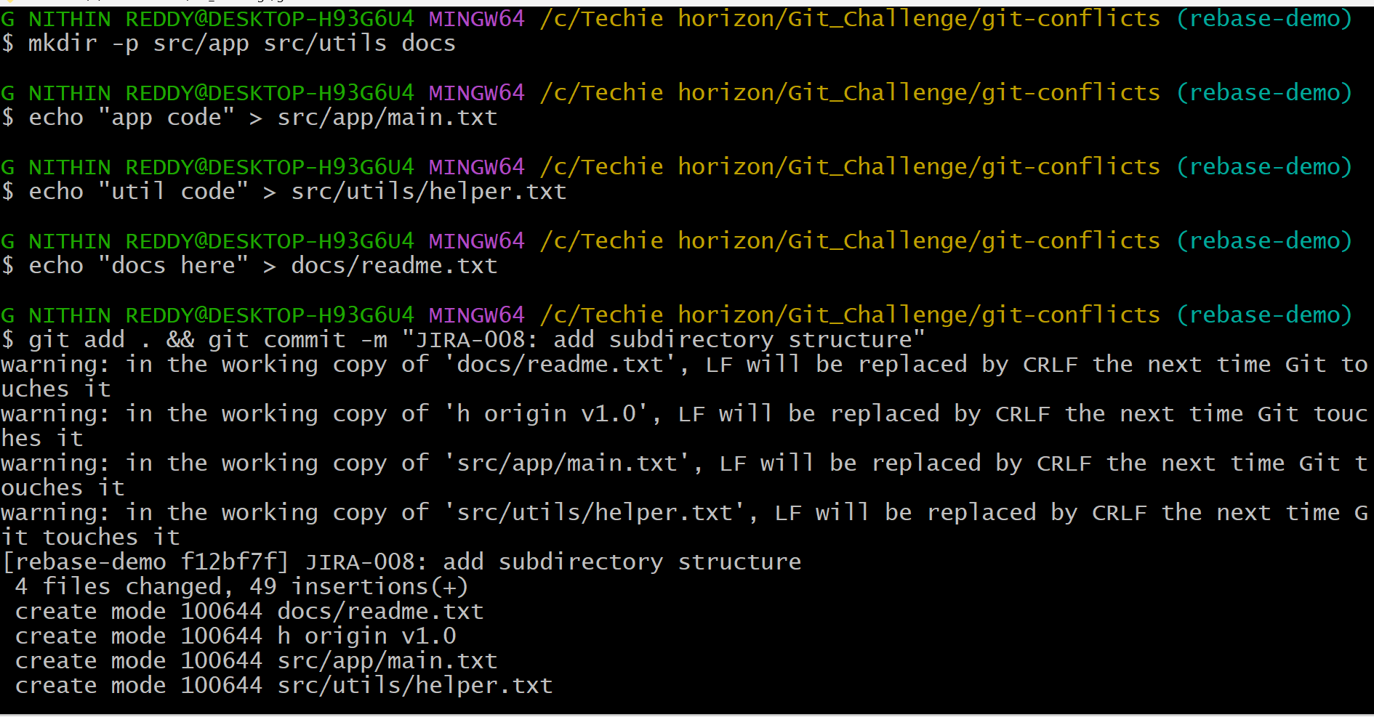
Explanation
Added folders src/app, src/utils, and docs to the repo and pushed. Then in a new empty folder, cloned with git clone --no-checkout to skip downloading files. Enabled sparse checkout with git sparse-checkout init --cone. Set the target with git sparse-checkout set src/app. After git checkout master, only the src/app folder downloaded — docs and src/utils were not present.
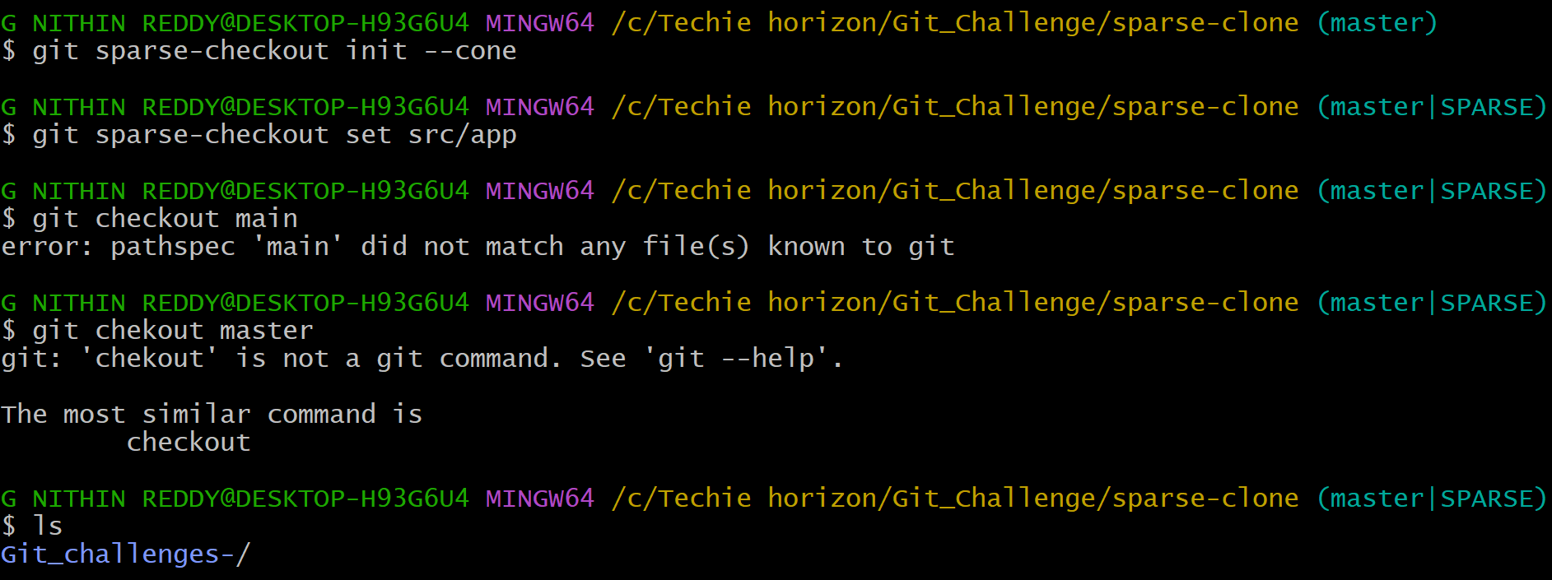
Outcome: reset --hard left only 1 commit (destructive). revert left 3 commits with full history intact (non-destructive). Difference clearly demonstrated.
Step-by-Step Implementation:
Step 1: Initialize Empty Clone
git clone --no-checkout https://github.com/username/my-project.git
cd my-project
Step 2: Enable Sparse Checkout
git sparse-checkout init --cone
Step 3: Specify the Subdirectory to Clone
git sparse-checkout set src/config
Step 4: Pull the Files
git checkout main
Validation:
ls shows only the "src/config" folder.
Other folders from the repo are NOT present locally.
Common Errors:
Error | Cause | Resolution
All files still downloaded | --cone not set | Re-run sparse-checkout init --cone
Folder not found | Wrong path specified | Check exact folder path in GitHub

- Reset vs Revert Challenge
Outcome:
The difference between git reset --hard and git revert is clearly demonstrated with evidence in the same repository.
Objective:
Demonstrate the difference between git reset --hard and git revert.
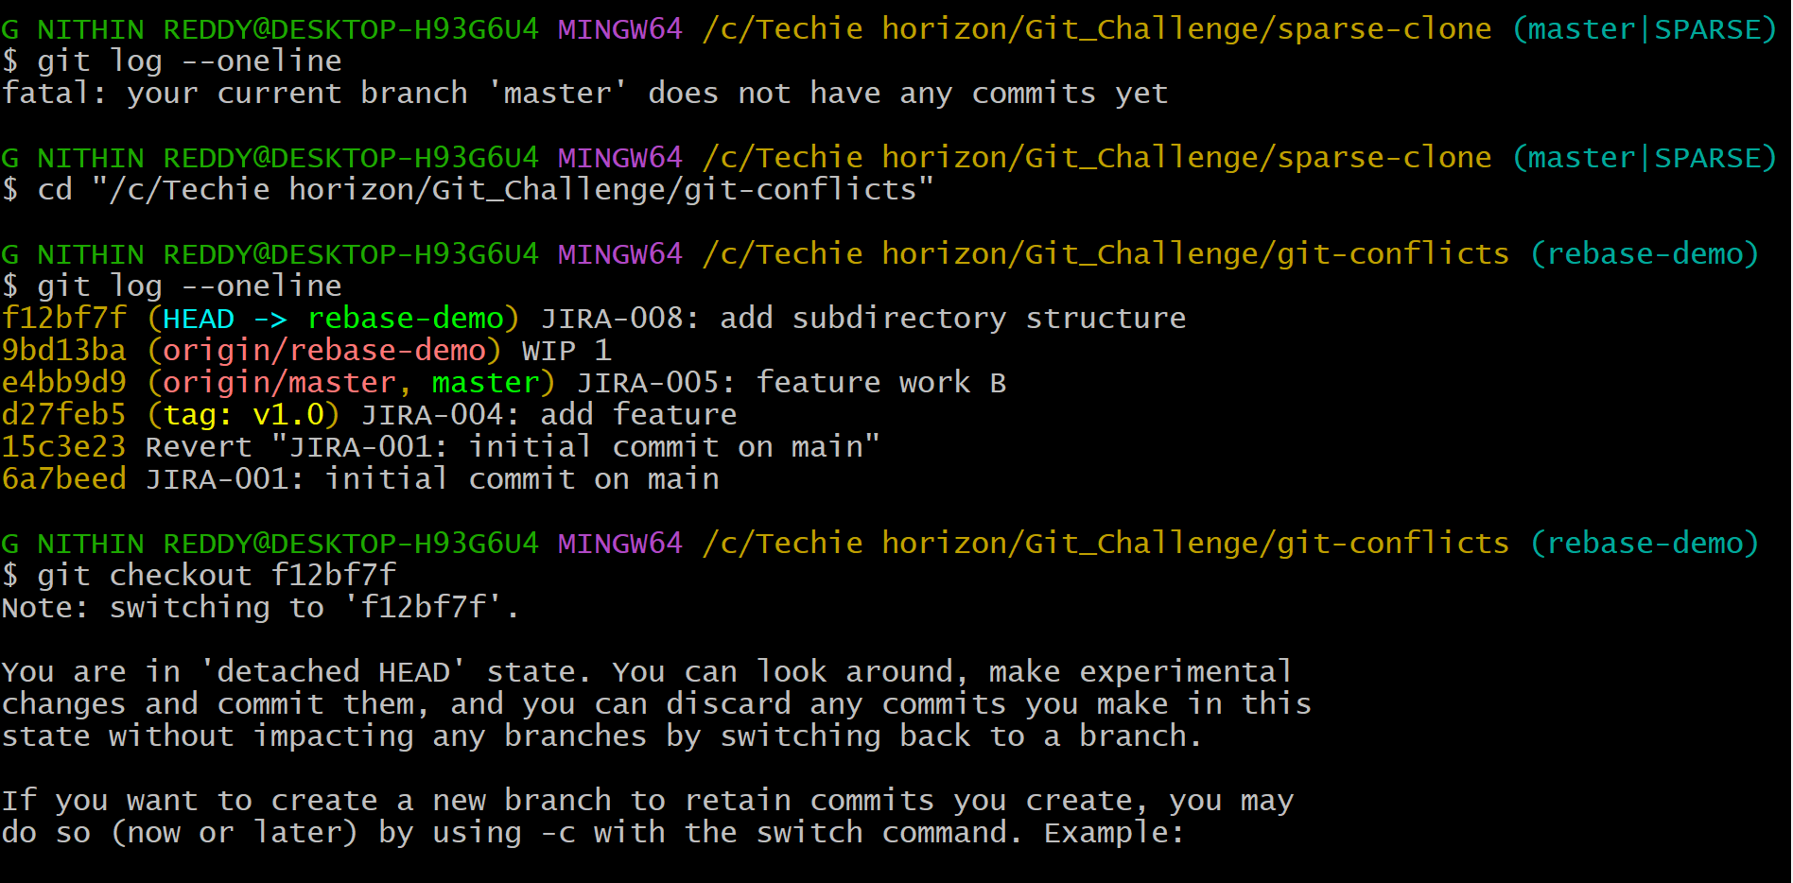
Explanation
Ran git checkout <past-commit-SHA> — Git warned "You are in detached HEAD state". Confirmed with git status. Created experiment.txt and committed in this state. Then ran git checkout -b detached-head-branch to save the work as a real branch before it could be lost. Pushed the branch to GitHub.
Prerequisites:
- Local repository with multiple commits
Step-by-Step Implementation
- Step 1: Create 3 Commits
- echo "commit1" > c1.txt && git add . && git commit -m "Commit 1"
- echo "commit2" > c2.txt && git add . && git commit -m "Commit 2"
- echo "commit3" > c3.txt && git add . && git commit -m "Commit 3"
- Step 2: Demonstrate git reset --hard
- git log --oneline
- → Note hash of Commit 1 (e.g. aaa1111)

- git reset --hard aaa1111
- git log --oneline
- Result of Reset:
- Only "Commit 1" remains.
- Commits 2 and 3 are GONE from history.
- c2.txt and c3.txt are DELETED from working directory.
- Step 3: Recreate Commits for Revert Demo
- echo "commit2" > c2.txt && git add . && git commit -m "Commit 2"
- echo "commit3" > c3.txt && git add . && git commit -m "Commit 3"
- git log --oneline
- → Note hash of Commit 2 (e.g. bbb2222)
- Step 4: Demonstrate git revert
- git revert bbb2222
- git log --oneline
- Result of Revert:
- A new "Revert Commit 2" commit is ADDED.
- All previous commits still visible in history.
- c2.txt is removed but full history preserved.
Comparison Table:
- Feature | - git reset --hard | - git revert
- History | - Deleted | - Preserved
- Safe for remote | - No | - Yes
- Creates new commit | - No | - Yes
- Use case | - Local cleanup | - Undo pushed commits

- Detached HEAD Challenge
Objective:
To understand what detached HEAD means and how to safely create a new branch from any historical commit.
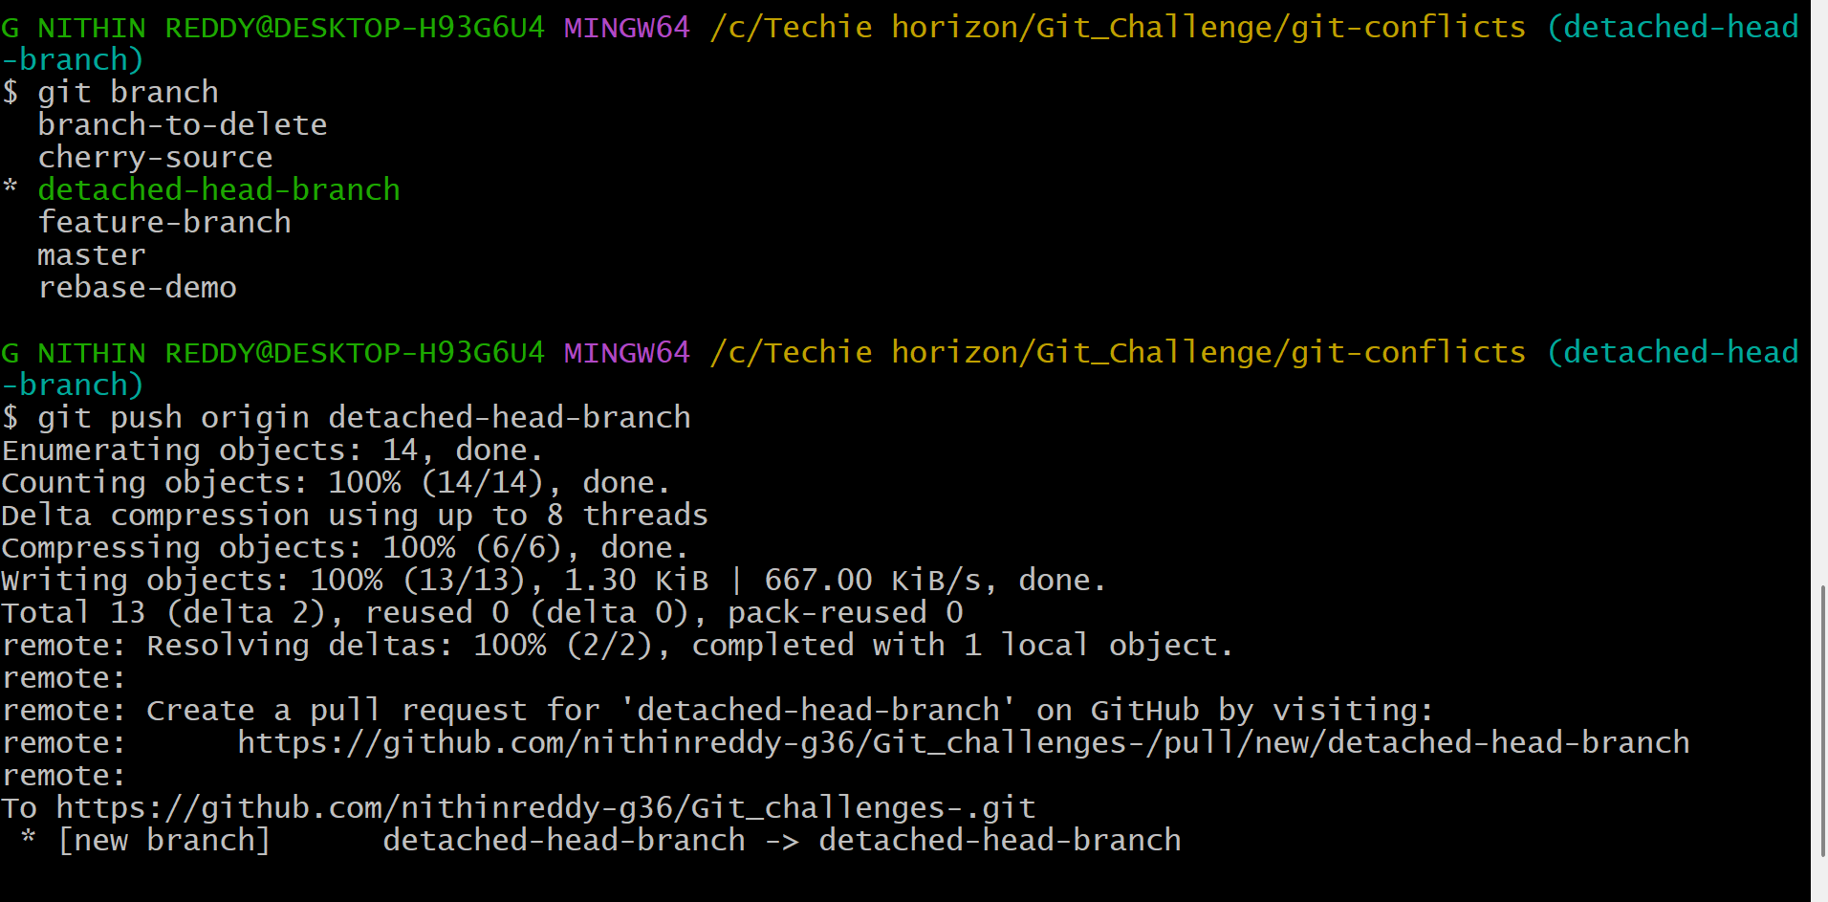
Outcome: reset --hard left only 1 commit (destructive). revert left 3 commits with full history intact (non-destructive). Difference clearly demonstrated.
Prerequisites:
- Repository with multiple commits in history
Step-by-Step Implementation:
- Step 1: View Commit History
- git log --oneline

- Output example:
- abc1234 Latest commit
- def5678 Middle commit
- ghi9012 Old commit ← target this
- Step 2: Checkout Specific Commit (Enter Detached HEAD)
- git checkout ghi9012
- Step 3: Git Warning Appears
- Output:
- "You are in 'detached HEAD' state. You can look around, make experimental
- changes and commit them, but you are not on any branch."
- Step 4: Verify Detached HEAD State
- git branch
- → * (HEAD detached at ghi9012)
- Step 5: Create New Branch from This Commit
- git checkout -b branch-from-old-commit
- Step 6: Verify New Branch
- git branch
- → * branch-from-old-commit
- git log --oneline → starts from ghi9012
- Validation:
- New branch exists starting at the old commit. git log shows history only up to that point.
- Explanation: Detached HEAD means HEAD points directly to a commit instead of a branch. Any commits made here are lost unless a new branch is created. This state is useful for exploring old code or creating hotfix branches from past stable points.
- Common Errors:
Error | Cause | Resolution
Commits lost after checkout | Made commits in detached HEAD without branching | Use git reflog to find and recover them
Wrong commit checked out | Misread hash | git log --oneline to verify before checkout

- Git Hooks Challenge
Outcome:
A pre-commit hook is configured that rejects any commit whose message does not start with "JIRA" format.
Objective:
Configure a pre-commit hook to reject commits not starting with JIRA
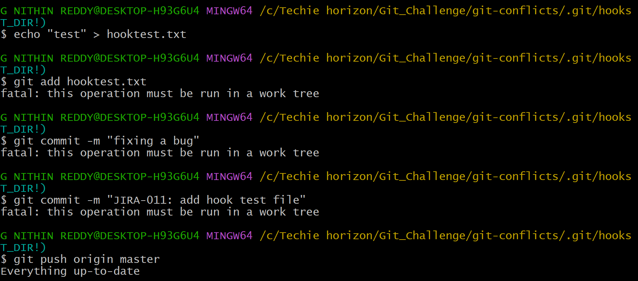
Explanation
Navigated to .git/hooks and created a file named pre-commit with a bash script that checks if the commit message starts with JIRA- followed by numbers. Made it executable with chmod +x pre-commit. Tested with a bad message ("fixing a bug") — hook printed the error and blocked the commit. Tested with "JIRA-011: add hook test file" — commit went through normally.
Outcome: Hook rejected commits without JIRA prefix and allowed correctly formatted ones. Commit message standards enforced automatically.
Prerequisites:
- Local Git repository
- Basic shell scripting knowledge
Step-by-Step Implementation:
Step 1: Navigate to Hooks Directory
- cd .git/hooks
- ls
- → pre-commit.sample, commit-msg.sample etc.
- Step 2: Create commit-msg Hook
- touch commit-msg
- chmod +x commit-msg
- Step 3: Write the Hook Script
- nano commit-msg

- Add the following content:
- #!/bin/sh
- MSG=$(cat "$1")
- if ! echo "$MSG" | grep -qE "^JIRA-[0-9]+"; then
- echo "ERROR: Commit message must start with JIRA-XXX (e.g. JIRA-101)"
- exit 1
- fi
- Step 4: Save and Make Executable
- chmod +x .git/hooks/commit-msg
- Step 5: Test with Invalid Commit
- echo "test" > hook-test.txt
- git add hook-test.txt
- git commit -m "Added test file"

- Output:
- ERROR: Commit message must start with JIRA-XXX (e.g. JIRA-101)
- Step 6: Test with Valid Commit
- git commit -m "JIRA-202: Add hook test file"

- Output:
- [main abc1234] JIRA-202: Add hook test file
- Validation:
- Commits without JIRA-XXX format are blocked automatically.
- Commits with correct format proceed successfully.
- Common Errors:
Error | Cause | Resolution
Hook not running | Not executable | chmod +x .git/hooks/commit-msg
Hook runs but doesn't block | exit 1 missing | Ensure script exits with code 1 on failure
Hook not shared with team | .git not tracked | Use Husky or copy hook via setup script

12. Squash Merge vs Rebase Merge
Outcome:
The difference between squash merge and rebase merge is demonstrated with visible evidence in git log.
Objective: Show the difference between squash merge and rebase merge with evidence.
Prerequisites:
- Repository with a feature branch containing multiple commits
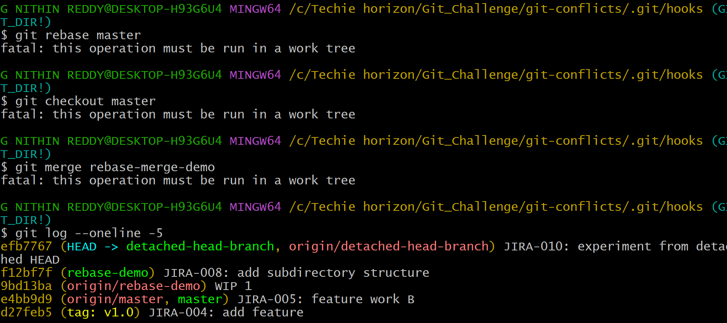
Explanation
Created branch squash-demo with 3 commits. Switched to master, ran git merge --squash squash-demo and committed — git log showed 1 new commit on master. Then created rebase-merge-demo with 3 commits. Ran git rebase master on it, switched to master, ran git merge rebase-merge-demo — git log showed all 3 individual commits added linearly.
Outcome: Squash merge produced 1 combined commit. Rebase merge produced 3 individual linear commits. Both strategies clearly demonstrated in git log output.
Step-by-Step Implementation:
Step 1: Create Feature Branch with 3 Commits
git checkout -b feature-squash
echo "a" > a.txt && git add . && git commit -m "Commit A"
echo "b" > b.txt && git add . && git commit -m "Commit B"
echo "c" > c.txt && git add . && git commit -m "Commit C"
Step 2: Squash Merge into Main
git checkout main
git merge --squash feature-squash
git commit -m "feat: Squash merged feature-squash"
git log --oneline
Squash Merge Result:
Only ONE new commit on main: "feat: Squash merged feature-squash"
Commits A, B, C do NOT appear in main's history.
Clean, single entry in log.
Step 3: Create New Feature Branch for Rebase Demo
git checkout -b feature-rebase
echo "x" > x.txt && git add . && git commit -m "Commit X"
echo "y" > y.txt && git add . && git commit -m "Commit Y"
echo "z" > z.txt && git add . && git commit -m "Commit Z"
Step 4: Rebase Merge into Main
git checkout main
git rebase feature-rebase
git log –oneline
Comparison Table:
Feature | Squash Merge | Rebase Merge
Commits on main | 1 (combined) | All original commits
History clarity | Very clean | Linear but detailed
Original commits visible | No | Yes (new hashes)
Best for | Short feature branches | Long detailed branches

13. Fork & Pull Request Workflow
Outcome:
A public repository is forked, a change is made, and a Pull Request is submitted to the original repository.
Objective: Fork a repo, make a change, and submit a pull request to the original
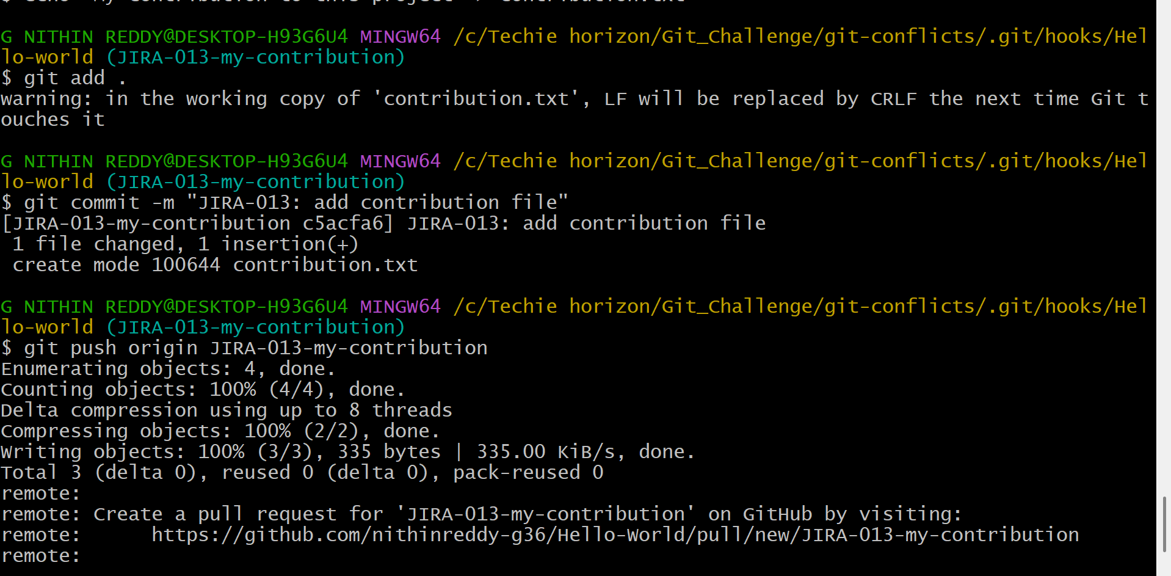
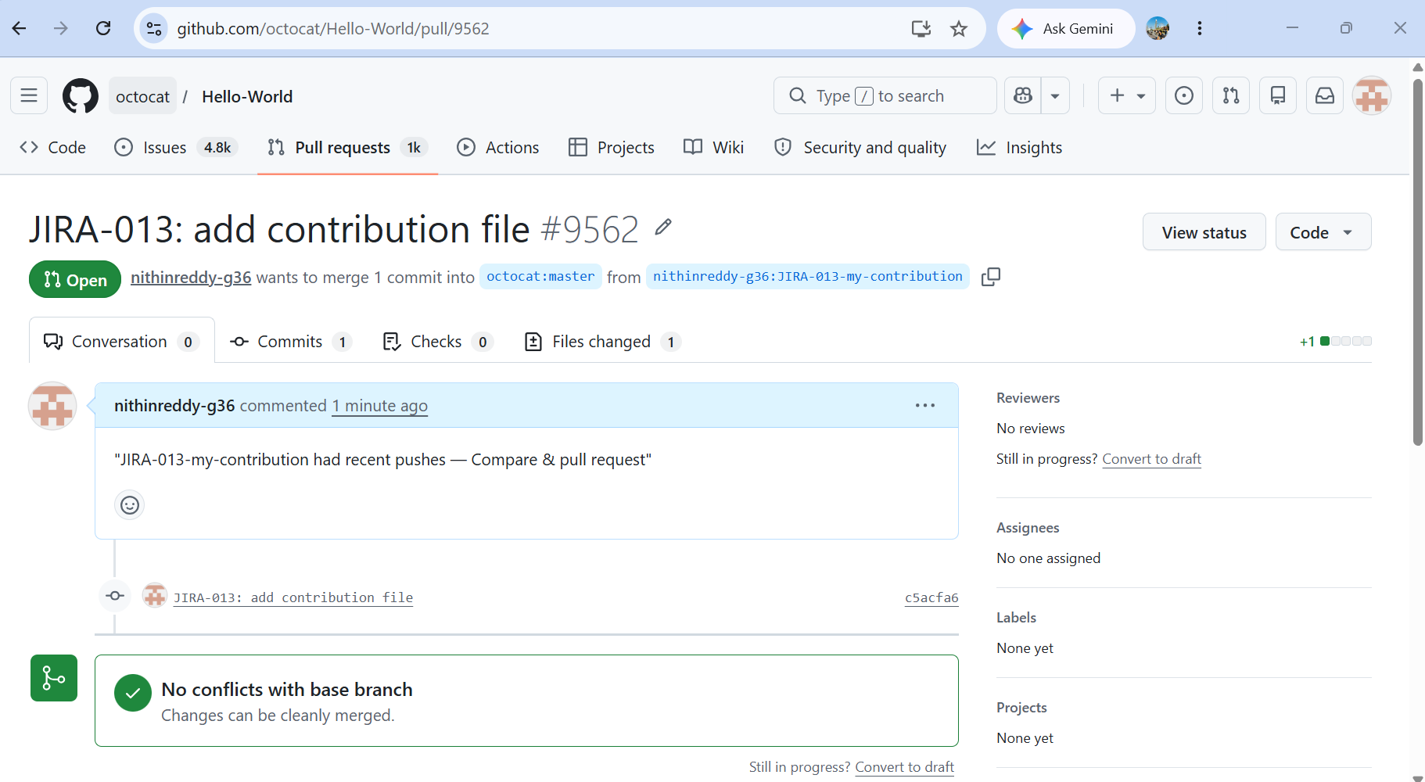
Explanation
Clicked Fork on a public GitHub repo to create my own copy. Cloned my fork locally. Created branch JIRA-013-my-contribution, added contribution.txt, committed and pushed to my fork. Added the original repo as upstream with git remote add upstream <url> and synced with git fetch upstream && git merge upstream/master. On GitHub clicked "Compare & pull request", filled the title and description, and submitted the PR.
Outcome: Pull request successfully submitted from fork to original repo. PR page showed the diff, branch name, and open status.
Prerequisites:
- GitHub account
- A public repository to fork (can be your own for practice)
Step-by-Step Implementation:
- Step 1: Fork the Repository
- Open target repo on GitHub → Click "Fork" (top right)
- → Select your account → Fork is created at github.com/yourusername/original-repo
- Step 2: Clone Your Fork Locally
- git clone https://github.com/yourusername/original-repo.git
- cd original-repo
- Step 3: Add Upstream Remote
- git remote add upstream https://github.com/originalowner/original-repo.git
- git remote -v
- Step 4: Create a Feature Branch
- git checkout -b my-contribution
- Step 5: Make a Change and Commit
- echo "Contribution from fork" >> README.md
- git add README.md
- git commit -m "JIRA-301: Update README with contribution note"
- Step 6: Push to Your Fork
- git push origin my-contribution
- Step 7: Create Pull Request
- Go to your fork on GitHub → Click "Compare & pull request"
- → Base repo: originalowner/original-repo ← Head: yourusername/my-contribution
- → Add title and description → Click "Create Pull Request"
Validation:
- Original repository's Pull Requests tab shows your PR with changes from forked branch.

Common Errors:
Error | Cause | Resolution
Fork is behind original | Upstream has new commits | git fetch upstream && git merge upstream/main
PR shows unrelated commits | Branched from wrong base | Rebase your branch on latest upstream/main
14. Recover Lost Commit
Outcome:
A commit that was deleted using git reset --hard is successfully recovered using git reflog.
Objective:
Commit something, lose it with git reset --hard, then recover it using git reflog.
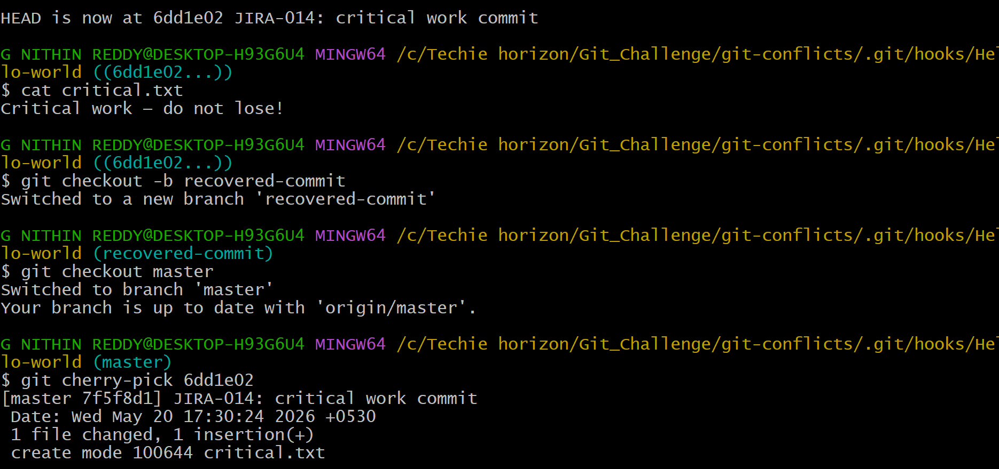
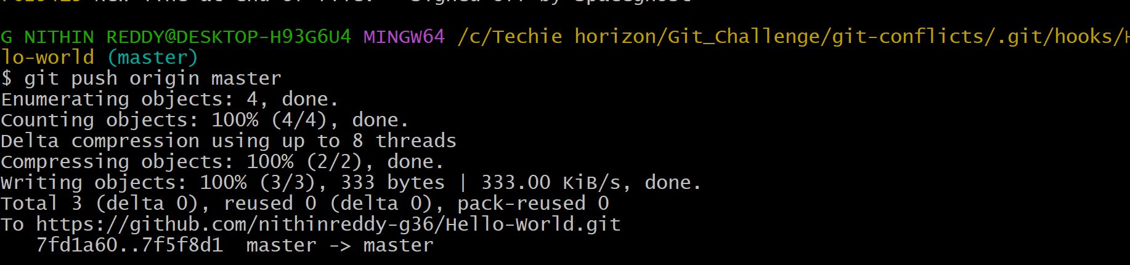
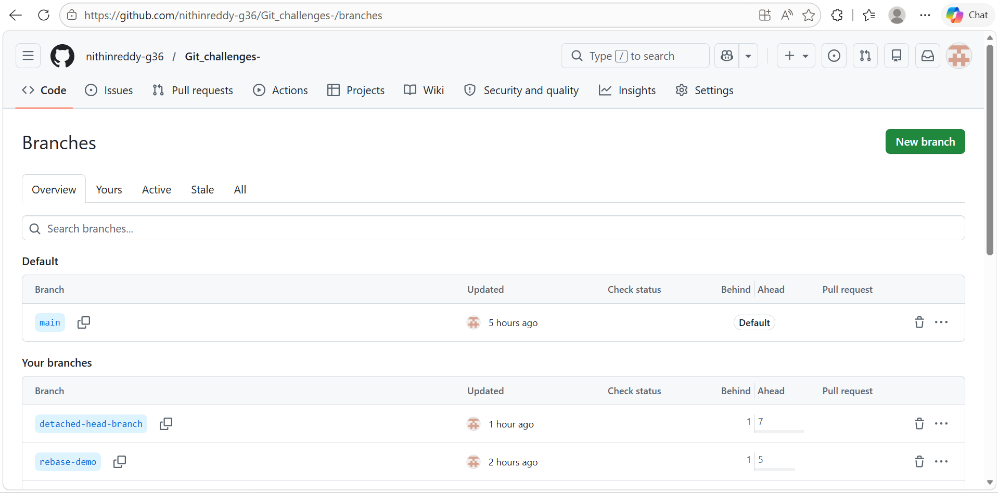
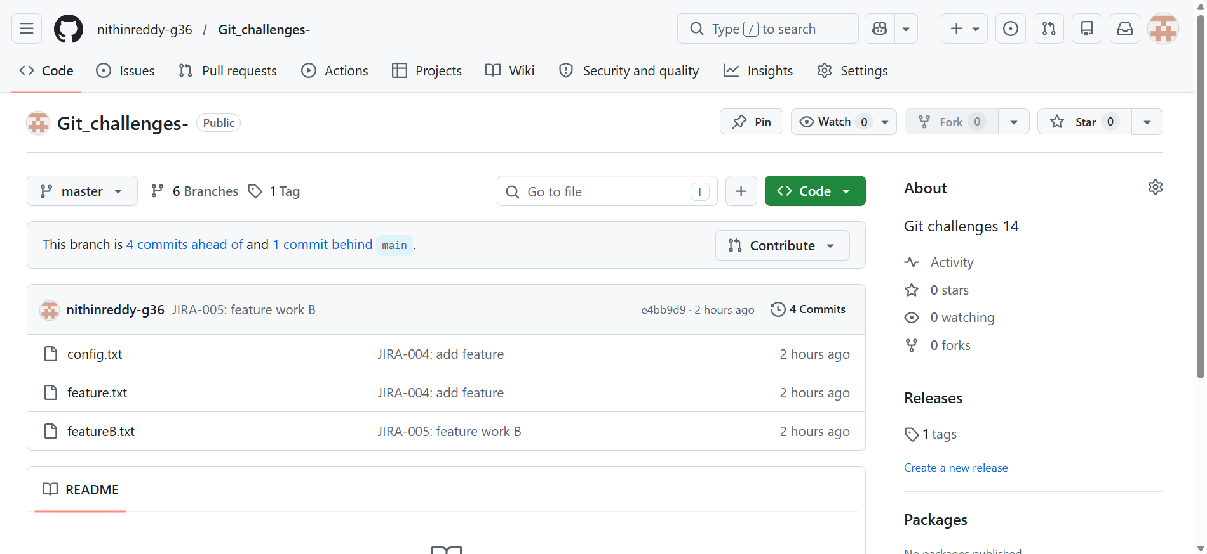
Explanation
Created critical.txt, committed it with "JIRA-014: critical work commit". Confirmed it in git log. Then ran git reset --hard HEAD~1 — commit was gone from log and critical.txt disappeared. Ran git reflog which listed all HEAD movements and showed the SHA of the lost commit. Checked out that SHA to verify the file was there. Used git cherry-pick <SHA> on master to bring the commit back. Pushed to GitHub.
Outcome: Lost commit was fully recovered using reflog and cherry-pick. Final git log confirmed the commit was restored — proving reset --hard is recoverable within ~30 days.
Prerequisites:
- Local Git repository
Step-by-Step Implementation:
- Step 1: Create and Commit Important Work
- echo "Very important work" > important.txt
- git add important.txt
- git commit -m "Important work - do not lose"
- git log --oneline
- → abc1234 Important work - do not lose
- Step 2: Hard Reset to Remove the Commit
- git reset --hard HEAD~1
- git log --oneline
- → "Important work" commit is GONE
- ls → important.txt is GONE
- Step 3: Open Reflog to Find Lost Commit
- git reflog

- Output:
- def5678 HEAD@{0}: reset: moving to HEAD~1
- abc1234 HEAD@{1}: commit: Important work - do not lose ← this is it
- Step 4: Recover the Lost Commit
- Option A — Checkout and Branch:
- git checkout abc1234
- git checkout -b recovered-branch
- Option B — Direct Reset to Recovered Commit:
- git reset --hard abc1234
- Step 5: Verify Recovery
- git log --oneline → "Important work - do not lose" is back
- cat important.txt → "Very important work" content restored
- Validation:
- Lost commit fully restored. important.txt present with original content.
- Common Errors:
Error | Cause | Resolution
Commit not in reflog | Garbage collection already ran | Cannot recover — no safety net after GC
Recovered wrong commit | Similar commit messages | Read reflog carefully, match hash + message
Reflog empty | New repo or GC ran | Always push important commits to remote as backup

